Table of Contents

1. Document Purpose..................................................3
2. Application Overview .............................................3
3. Testing Section ........................................................ 3
4. Testing Checklist ..................................................... 5
5. Detailed Test Case .................................................. 9
6. Founded Bugs ........................................................... 27
7. Test Design Techniques .......................................... 28
8. Reflection .................................................................... 28

# Document Purpose

The purpose of this document is to make the detailed manual test report done on the Wise web application. The Wise Application make the navigating and money transfer process should be easily accessible to its customer.

# Application overview

Wise Application is the forex based money transfer application. Money can be transfered across the globaal using the online facilities. There are serveral modules like personal account, business account,c comparision of money of diferent currency type which are integrated to fulfill the purpose.

# testing section

1. In Scope

Function testing for the following modules are in scope of testing

* Registration
* Login
* Functionality
* Performance testing
* Security testing

1. Out of Scope

Compactability testing was not done for this application.

3)Items not Tested

Money transactions in the business account could not be establish due to some technical limitations.This can be verified during UAT (user Acceptance Testing)

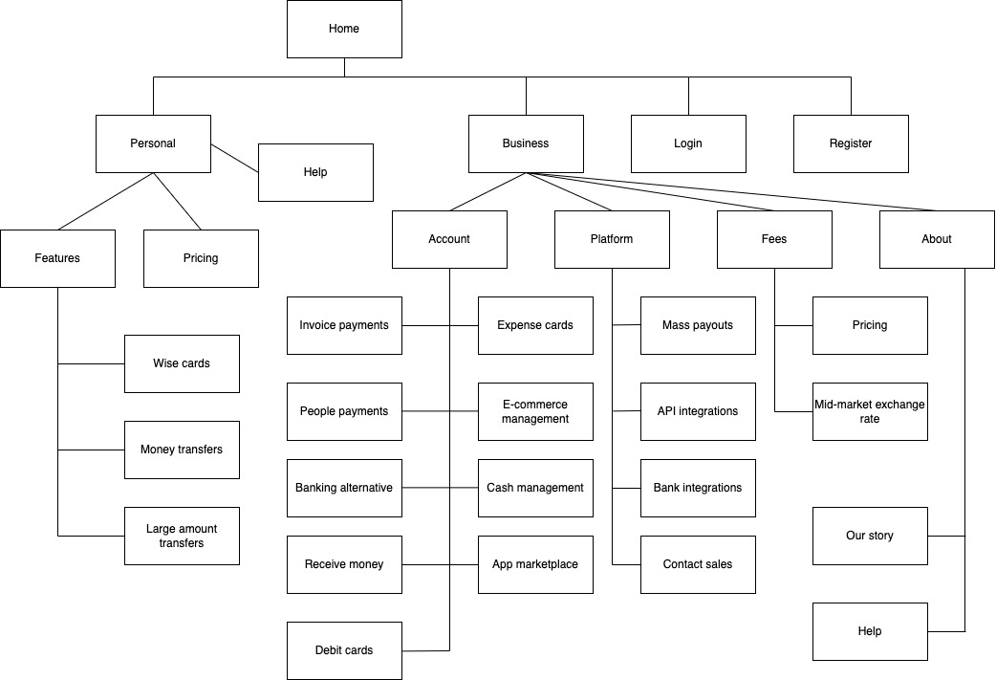

# testing checklist

# detailed test cases

Registration test case:

Login function Test case:

Functionality Test case:

Performance test case

Security test case

Usability Test case

# founded bugs/issues

# test design techniques

* Equivalence class paritioning
* Boundary Value Analysis
* Smoke Testing

This Testing was done whenever a build is received for Testing to make sure the major functionalities are working finne.

* System integration Testing

This is the Testing performed on the Application Under test,to verify the entire application works as per the requirements.(end-end testing)

* Regression Testing

Regression Testing was performed each time a new build is deployed for testing which contains defect fixes and new enchancement.

Regression Testing is being done on the entire application and not just the new functionalites and defect fixes.

Test case of new functionalities are added to the existing test case and executed.

# reflection

Exploratory Testing was executed without any difficulties within the overall approach of the testing.

Smoke testing test cases required to be executed manually each time.